VENANGO TECHNOLOGY CENTER
JOINT COMMITTEE
1 Vo-Tech Drive
Oil City, Pennsylvania 16301

MINUTES

November 2, 2020

The regular meeting of the Venango Technology Center Joint Committee was held this evening in the Conference Room of the Venango Technology Center, 1 Vo-Tech Drive, Oil City, PA 16301. Mrs. Neely called the meeting to order at seven o’clock (7:00) p.m.

Mrs. Neely asked the members to pause for a moment of silence.

Mrs. Neely asked the members to stand for the pledge of allegiance.

Roll Call: Present: Robert Blauser (zoom), Todd Carson, James Come (zoom), James Disque, Jeff
Thomas (zoom), Don Judy (zoom), Mark Marterella (zoom), Misty Nalepa (zoom),
Shari Neely

Absent: Troy Johnston

Also Present: Mr. Mario Fontanazza, Dr. Lynda Weller (zoom)

Mrs. Neely stated the Joint Committee members had received copies of the Minutes of the October 5, 2020 meeting in the mail. She asked if there were any additions, corrections or deletions.

Mr. Carson, seconded by Mr. Disque, moved to approve the Minutes of the October 5, 2020 meeting as submitted.

Roll Call: Ayes: Robert Blauser, Todd Carson, James Come, James Disque, Jeff Thomas, Don
Judy, Mark Marterella, Misty Nalepa, Shari Neely

Nayes: None, motion carried.

The Treasurer and Secretary’s Report as of 11/2/20 were submitted for information.

Mr. Carson, seconded by Mr. Disque, moved to accept the Treasurer and Secretary’s Report as of 11/2/20 as submitted.

The motion was unanimously approved.

A list of bills from 10/6/20 – 11/2/20 in the amount of $472,027.46 was presented for approval.

Mr. Carson, seconded by Mr. Disque, moved to approve the list of bills as presented.

Roll Call: Ayes: Robert Blauser, Todd Carson, James Come, James Disque, Jeff Thomas, Don
Judy, Mark Marterella, Misty Nalepa, Shari Neely

Nayes: None, motion carried.

Under Communications, Mr. Fontanazza discussed the Professional Advisory Committee. He also discussed the Calendar of Events for the month of November and the Monthly Enrollment Report as of 11/2/20 were submitted.

Mrs. Neely requested approval of the action items as presented. Item 8. a) i.- v. in one motion.

Mr. Carson, seconded by Mr. Disque, moved to approve action items ii.- v. as follows:

- Approve additions to the Occupational Advisory Committees.
- Accept resignation of Connie Kellogg, administrative assistant Practical Nursing Warren.
- Approve advertising for an administrative assistant at Warren LPN.
- Approve updated COVID-19 response plan.
- Approve bus driver additions.

Roll Call: Ayes: Robert Blauser, Todd Carson, James Come, James Disque, Jeff Thomas, Don
Judy, Mark Marterella, Misty Nalepa, Shari Neely

Nayes: None, motion carried.

Mr. Fontanazza reviewed his Issues/Activities for October 2020.

Mrs. Neely asked if there was any old business.

None was noted.

Mrs. Neely asked if there was any new business.

None was noted.

Upon motion by Mr. Carson, seconded by Mr. Disque,, the meeting adjourned at seven sixteen (7:16) p.m.

Recorded by
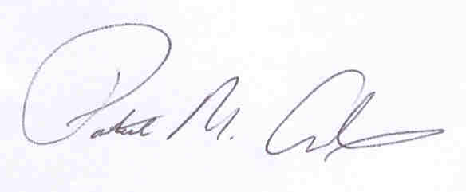
Patrick M. Adams
Secretary, Joint Committee

